Value of “this”

**GLOBAL CONTEXT**

In the global execution context (outside of any function), this refers to the global object whether in strict mode or not.

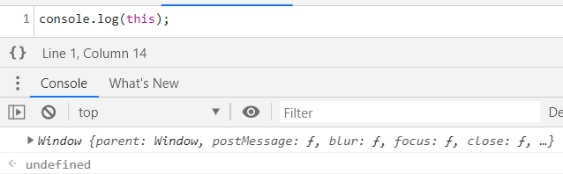

**FUNCTION CONTEXT**

**In strict mode:**

In strict mode, however, if the value of this is not set when entering an execution context, it remains as undefined, as shown in the following example**:**

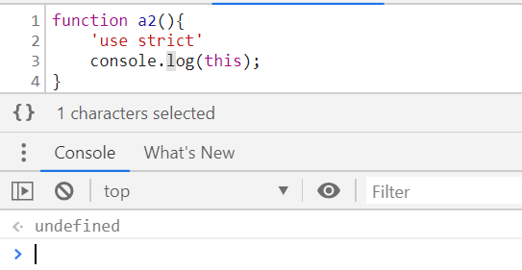

**Without Strict Mode:**

Because the value of this is not set by the call, this will default to the global object, which is [window](https://developer.mozilla.org/en-US/docs/Web/API/Window) in a browser.

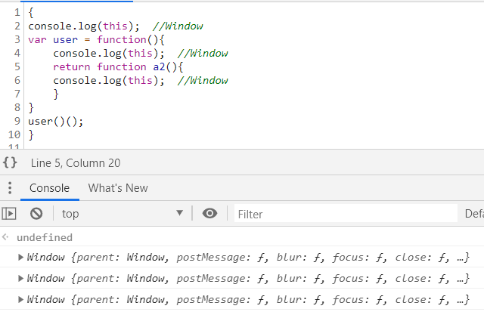

**DEPENDING ON HOW FUNCTION IS CALLED**

// An object can be passed as the first argument to call or apply and this will be bound to it.

var obj = {a: 'Custom'};

// This property is set on the global object

var a = 'Global';

function whatsThis() {

return this.a; // The value of this is dependent on how the function is called

}

whatsThis(); // 'Global'

whatsThis.call(obj); // 'Custom'

whatsThis.apply(obj); // 'Custom'

INSIDE OF AN OBJECT

